Product/Idea

Q.) What is the problem you are trying to solve?

Ans - A vast majority still relies on social media sites like linkedin, instagram, Facebook etc.

to know about various courses in various colleges, their eligibilities, placements, faculties, track records etc. This career decision is pivotal in one’s life and should be based while considering some credible ,certified and trustable sources. Our website aims in providing a one-click trustable solution for the same.

Q.) How does your idea address the problem?

Ans - in this site we provide one click solution to the students by which student can do successful transition to college through programs and services in college readiness.

Our user will save valuable time in researching about courses and experience through LinkedIn or other social media platforms, we are providing a one click solution.

Q.) Who are the target customers?

Ans - Our product will target high school student category, grad students pursuing master’s category and other interested youth or parents. So we are pitching our website to a big virtual audience.

Q.) What makes your idea unique?

Ans - Our product will turn out to be more trustable and accessible than other similar sites.

Our site has organised pre-analysed information in categories and comparisons, which will automatically give us an upper hand than other pre-existing sites.

Q.) Do you have a revenue generation model?

Ans - We do not intend to have a source of revenue yet, other than Adsense(money through advertisements(provided by google)) etc.

Q.) What are the geographies, do you think the idea would be suitable for?

Ans - Our website will provide informations on colleges located in India or open courses offered by colleges throughout india. People can shortlist colleges and courses according to their location.

Q.) What are the risks associated with your idea and how can you mitigate it?

Ans - Risk - Contains sensitive data which will be vulnerable if not secured properly.

Mitigation - We are using MongoDB to store our data, it’s inbuilt data security protocols ensure safety of our data.

Q.)   Who are the stakeholders involved in order to take bring this idea/product/service to the market?

Ans - Central Government will be our assumed stakeholders for ensuring AICTE approval and getting the info through ministry of education of institutes throughout the country.

Intellectual Property Assessment

Q.) Is your idea patentable or patented?

Ans - Our idea is not patentable as such because there do exist some sites which aims to provide a similar platform to people.

Q.) Is your idea built existing work? If so how is it different?

Ans - Yes, our prototype is complete and is up working with some basic features currently, we will make it better after our evaluation at internal hackathon.

Prototype/ Proof of Concept

Q.) What is the nature of the prototype/ proof of concept, you would be able to submit?

(Ex: Github repository, Hardware prototype)

Ans - We will submit our GitHub repository’s link for the project details.

Github repo link - https://github.com/Tarun-kishore/BroSure-brute4s

Q.) Have you completed pilot tests for your prototype/POC?

Ans - We haven’t conducted any tests for our website yet.

Q.) What is the approximate cost of developing the prototype?

Ans - There is no such apparent cost in developing our website, but to host it on the internet and getting AICTE’s approval + SSH approval, we will require some investment.

Q.) Please share the relevant elements while submitting the POC/ Prototype

Ans - BLOCK DIAGRAM -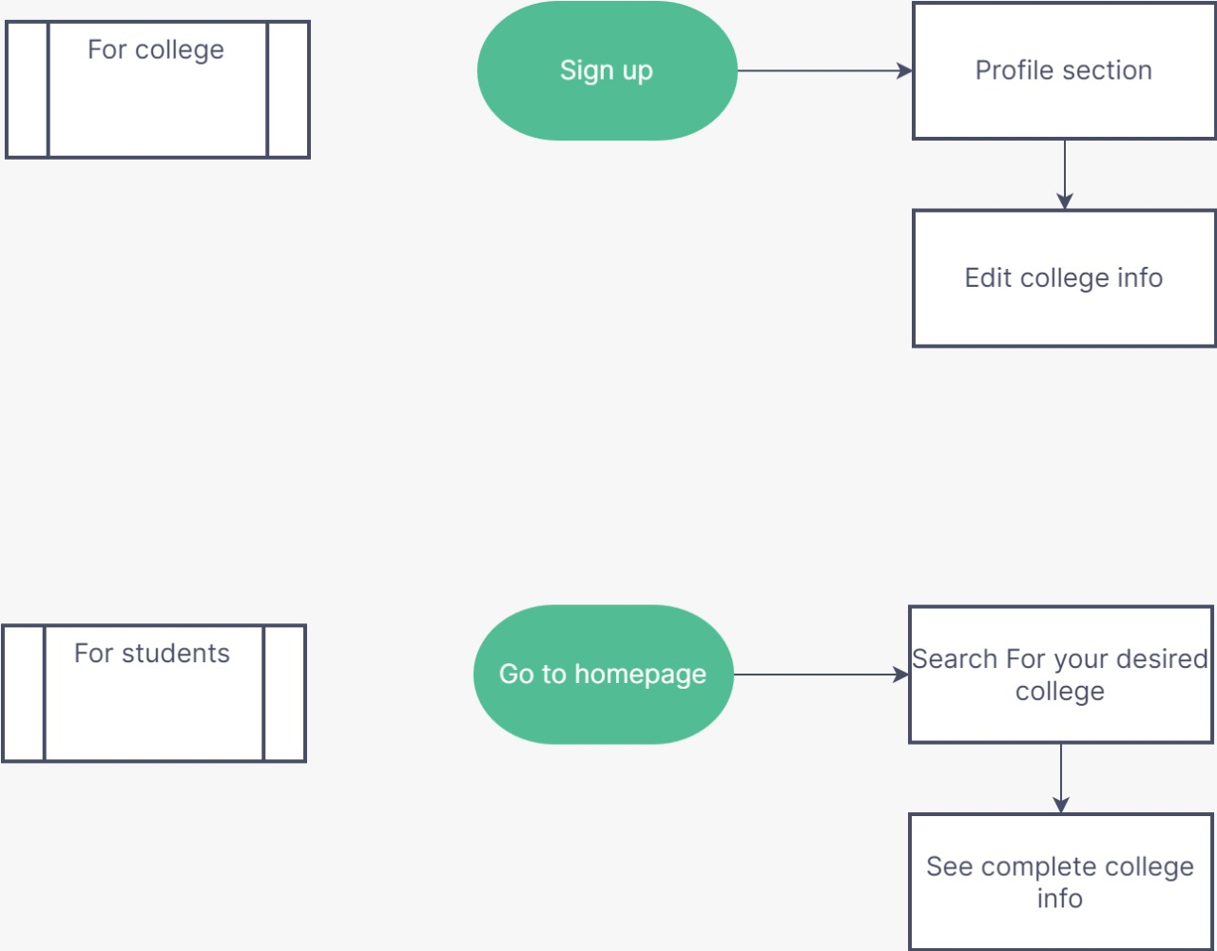

Supporting details

Q.) What regulatory requirements have to be met to bring the idea to life?

Ans - A database of multiple colleges, their courses offered and their track records will be required.

A College committee to edit a college info would be required and their TnP cells’ placement data will also be required.

Q.) Do you have a business plan/ commercialization strategy? If so please share.

Ans - Currently, we are developing this site for government aid and as a free-utility for students.  
We can definitely monetise further add-ons in our website independently, and can release derivatives as a whole after this project’s success in penetrating the education market.

Q.) What is rough estimate of manufacturing/operational costs?

Ans - As such no manufacturing and operational cost is required. We do need to maintain our site regularly and a huge database to store our data.

Q.) What is volume of products/ amount of revenue do you expect to make in the first year?

Ans - We do not expect any volume/ revenue through our project as our project currently is a non-profit utility, meant as aid to interested students.